NAME: Ayush Jambhule 2223835 -A
ENROLLMENT: MITU22BTCSDO212
SUBJECT: HPCL
ASSIGNMENT 3

Question 1: Write a C program that adds two integer arrays A and B, each containing N elements, and stores the result in array C. Parallelize the addition using parallel for.
Solution:( CODE)
#include <stdio.h>
#include <omp.h>
#define N 10
int main() {
int A[N], B[N], C[N];
for (int i = 0; i < N; i++) {
A[i] = i + 1;
B[i] = (i + 1) * 2;
}
#pragma omp parallel for
for (int i = 0; i < N; i++) {
C[i] = A[i] + B[i];
}
printf("Array C after parallel addition:\n");
for (int i = 0; i < N; i++) {
printf("%d ", C[i]);
}
return 0;
}
Expected Output:
Array C after parallel addition:
3 6 9 12 15 18 21 24 27 30
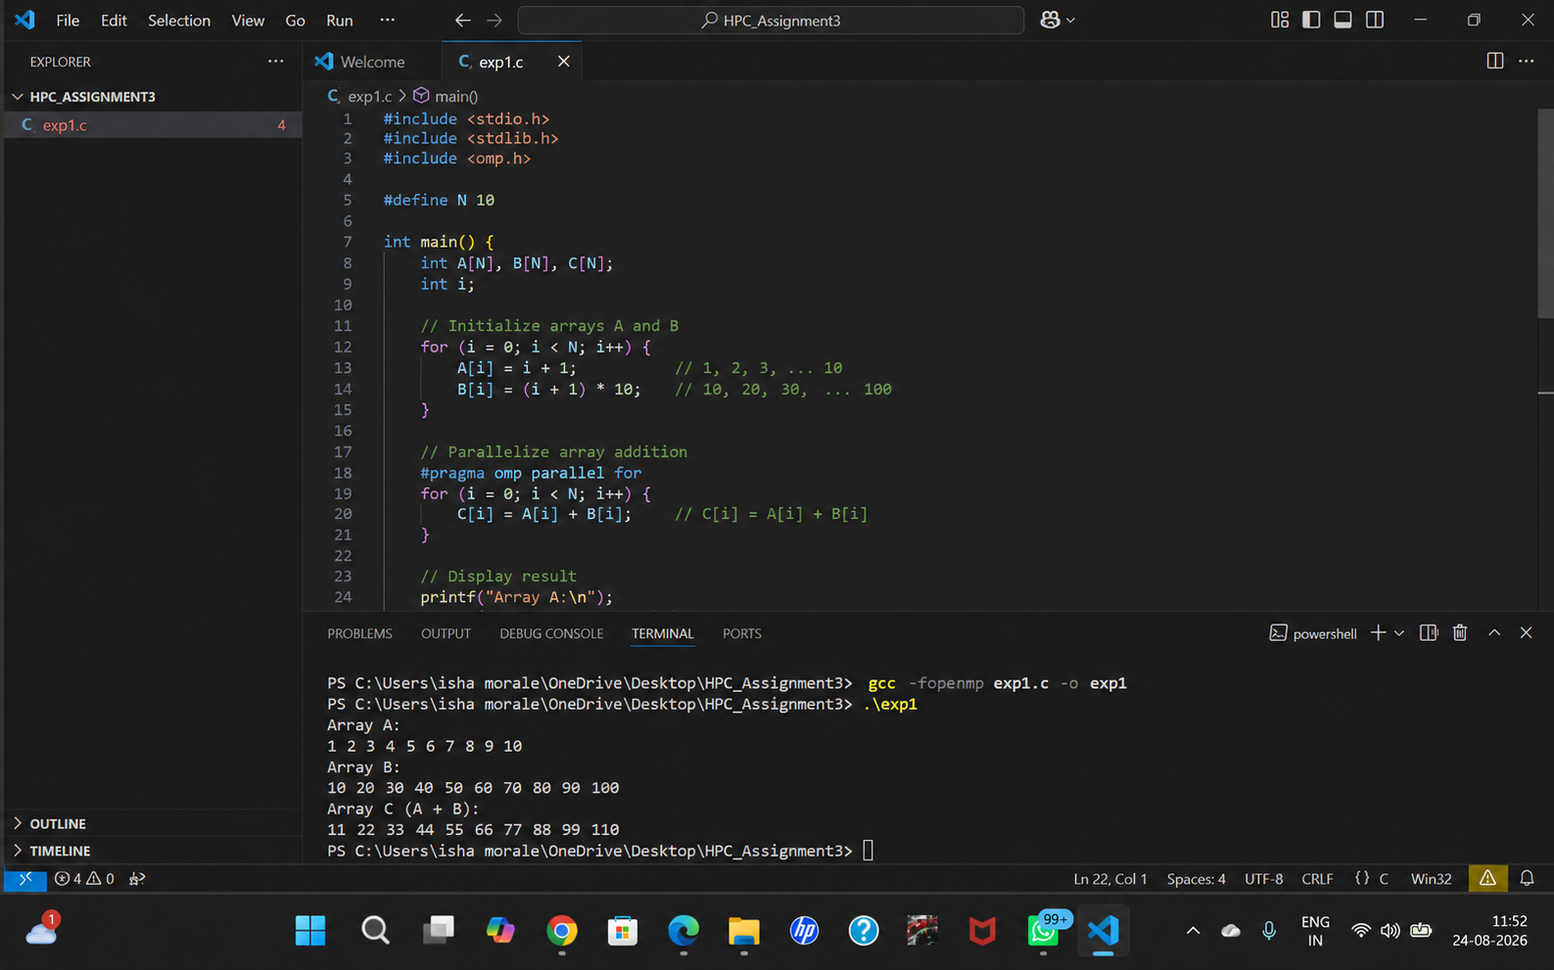

Question 2: Write a C program that calculates the sum and average of N floating-point numbers stored in an array. Identify the shared variable and parallelize it using reduction.
Solution:(code)
#include <stdio.h>
#include <omp.h>
#define N 5
int main() {
float A[N] = {10.5, 20.0, 30.5, 40.0, 50.0};
float sum = 0.0, average;
#pragma omp parallel for reduction(+:sum)
for (int i = 0; i < N; i++) {
sum += A[i];
}
average = sum / N;
printf("Sum = %.2f\n", sum);
printf("Average = %.2f\n", average);
return 0;
}
Expected Output:
Sum = 151.00
Average = 30.20
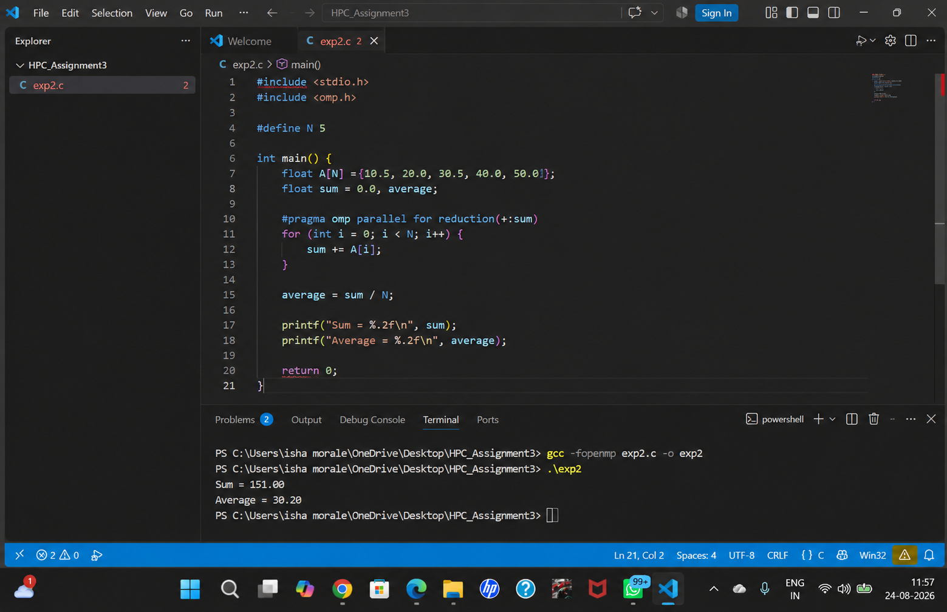
Question 3: Write a C program that finds the largest value in an integer array and reports its index.
Solution:(code)
#include <stdio.h>
#include <limits.h>
#include <omp.h>
#define N 10
int main() {
int A[N] = {12, 45, 7, 90, 23, 56, 34, 78, 11, 65};
int max = INT_MIN;
int maxIndex = -1;
#pragma omp parallel
{
int localMax = INT_MIN;
int localIndex = -1;
#pragma omp for nowait
for (int i = 0; i < N; i++) {
if (A[i] > localMax) {
localMax = A[i];
localIndex = i;
}
}
#pragma omp critical
{
if (localMax > max) {
max = localMax;
maxIndex = localIndex;
}
}
}
printf("Largest value = %d\n", max);
printf("Index of largest value = %d\n", maxIndex);
return 0;
}
Expected Output:
Largest value = 90
Index of largest value = 3
